* **What is collection:** Any group of individual objects which are represented as a single unit is known as the collection of the objects.
* **What is Framework:** A framework is a set of classes and interfaces which provide a ready-made architecture.
* **Collection Framework:** It is a java API which provides architecture to store and manipulate group of objects.
* **Basically this is stl in java.**
* **Collection Hierarchy**:
  + **Iterable**
    - For-each,
    - ListIterator->List
    - Iterator/for-each ->Set
    - Enumration->Vector
  + Collection
    - List: Indexed Collection, Order Preserved, Duplicates allowed
      * Array List: Dynamic Array,non – thread safe
      * Linked List: Doubly L.L.
      * Vector: Dynamic Array (Legacy class), thread safe
        + Stack
    - Set: Not Indexed coll. Order not preserved, Duplicates not allowed
      * HashSet
        + Linked Hashset
      * SortedSet
        + TreeSet(BST),sorted asc num,

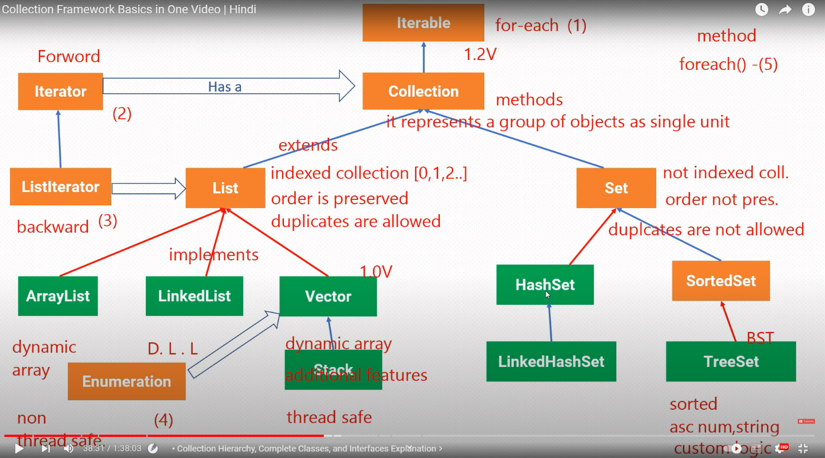

* **Map:** Key:value pair
  + HashMap
    - LinkedHashMap
  + SortedMap
    - TreeMap

